# Digital Verification using SV and UVM

# Assignment-3

# Name: Fares Khalaf Sultan

# Q1) ALU:

# Package Code:

# 

# 

# 

# testbench:

# 

# 

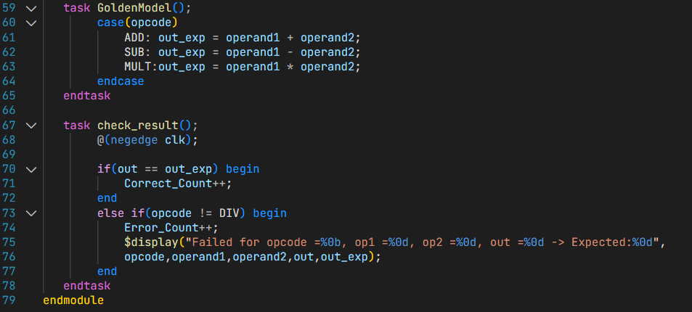

# Do file:

# Result:



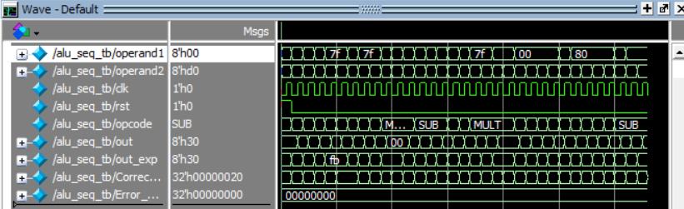Waveform:

# Functional coverage:

# 

# Code coverage:

**Excluded the default case for the opcode, because it is unreachable since all possible opcode values are handled in the case statement.**

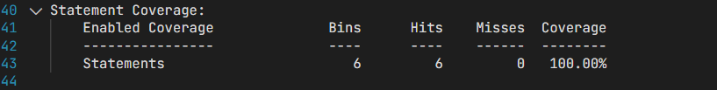

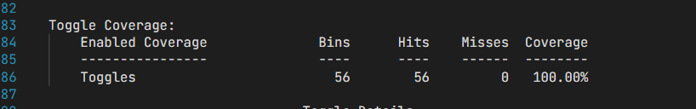

# Q2) Counter:

# Verification Plan:

|  |  |  |  |  |
| --- | --- | --- | --- | --- |
| **Label** | **Design Requirement Description** | **Stimulus Generation** | **Functional Coverage** | **Functionality Check** |
| Counter1 | when reset is asserted, Output should be low, and **zero** should be high | Directed at the start of the simulation, then randomized with constraint to be inactive 90% of time during the simulation | - | A checker in the testbench to make sure the output is correct |
| Counter2 | When **load_n** is low, **count_out** should take the value of **load_data** input | Randomization with constraint on **load_n** to be high 70% of simulation time | Cover all values of load_data | Output Checked against golden model |
| Counter3 | Counter should only increment or decrement if **rst_n** is inactive and, **ce** signal is high else keep the current **count_out** value. | Randomization with constraint on **ce** to be high 70% of simulation time | Cover all values of count_out& transition bin from max to zero | Output Checked against golden model |
| Counter4 | If rst_n is disabled and ce is enabeled, if: **up_down = o → decrement**  **Up_down = 1 → increment** | Randomization with constraint on **up_down** to be high 50% of simulation time | Bin for decrement & another for increment | Output Checked against golden model |
| Counter5 | Check that when the bus **count_out** value equals the max possible value, **max_count** should be high | Randomized with no constraints | Bin for max_count | Output Checked against golden model |

# Constraints class:

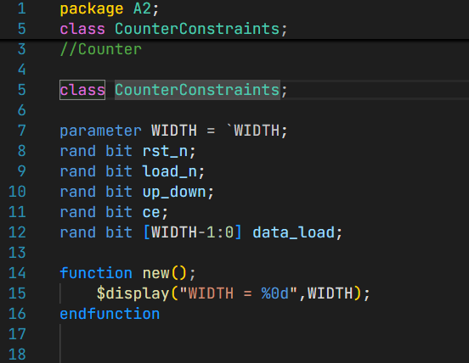

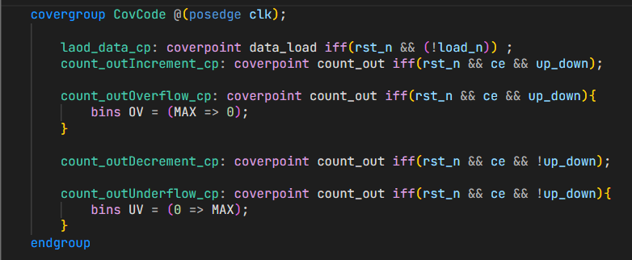

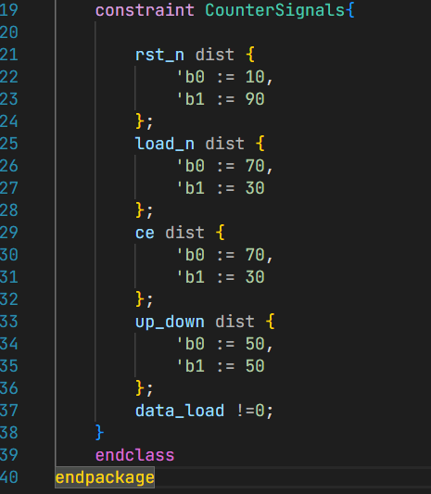

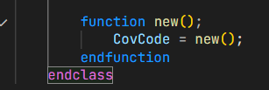

# Test bench:

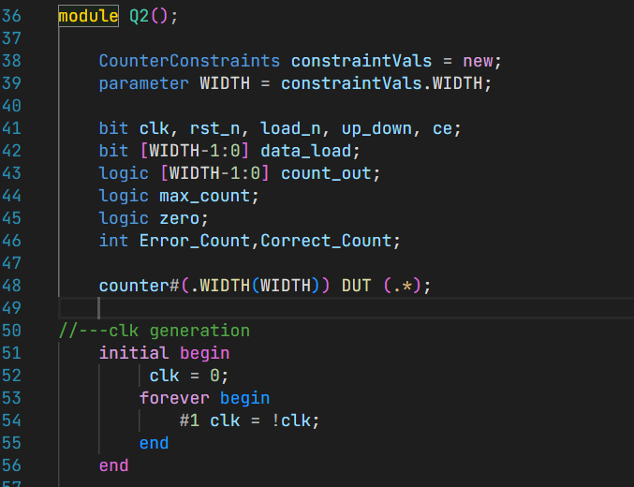

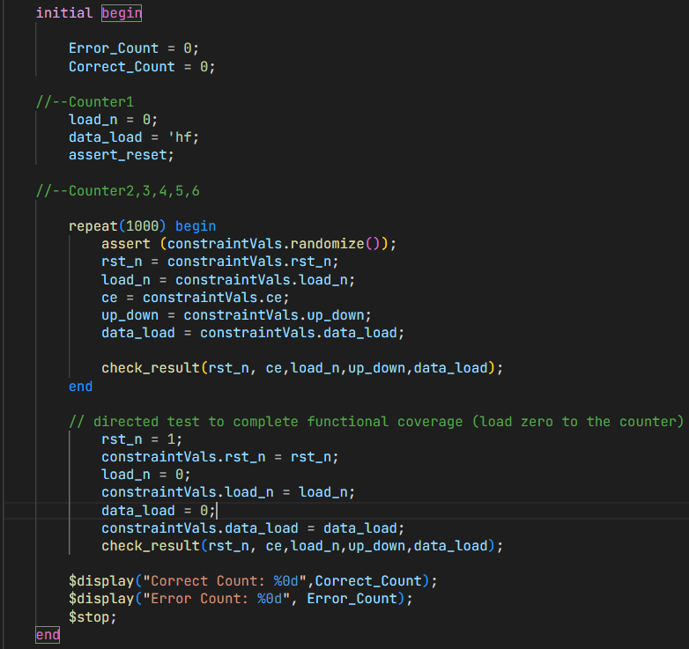

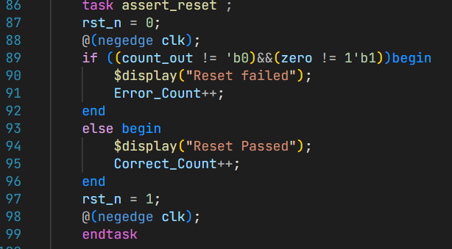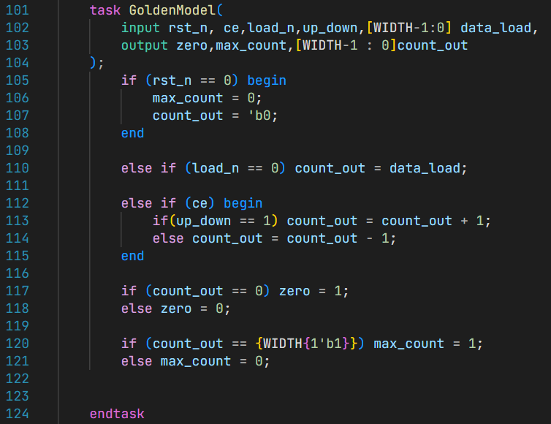

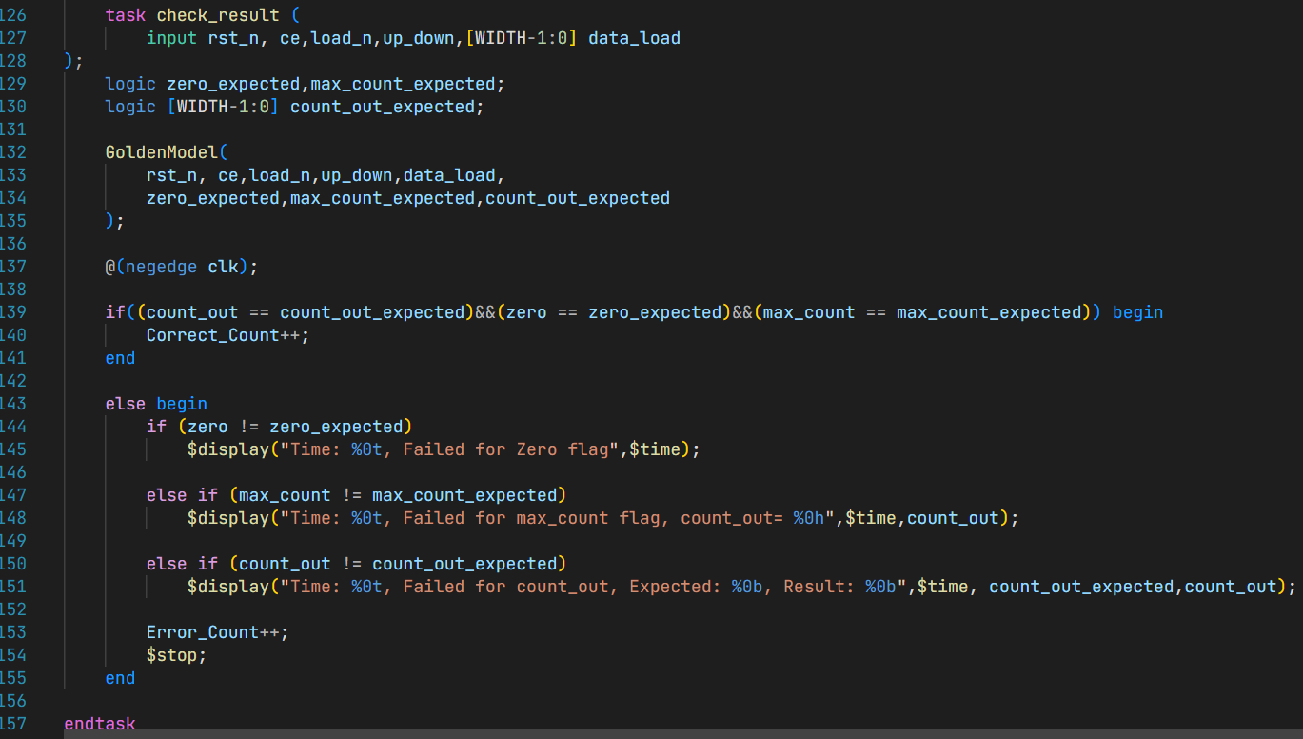

# Do file:

# 

# Result:

# 

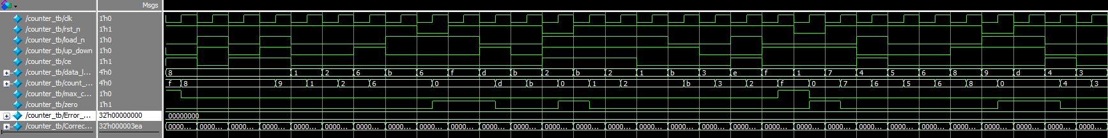Waveform:

# Functional Coverage:

# 

# Code Coverage :

# 

# 

# Q3) ALSU

# Verification Plan:

|  |  |  |  |  |
| --- | --- | --- | --- | --- |
| **Label** | **Design Requirement Description** | **Stimulus Generation** | **Functional Coverage** | **Functionality Check** |
| ALSU1 | when reset is asserted, Outputs should be Low for at least one clk cycle. | Directed at the start of the simulation | - | A checker in the testbench to make sure the output is correct |
| ALSU2 | In case opcode = ADD/MULT, & no invalid case, **LEDs** should = 0 &**out** should = A + B or A*B | Randomized under constraint of having A and B equals to( Max., Min., Zero) most of the time, | **Bins_arith[],** Ensures the happeness of this opcode values. | Comparing results to a refrence golden model |
| ALSU3 | If **opcode = OR/XOR** and no invalid cases, if both red_op_A/B are low, **out = A OR/XOR B**, else if red_op_A is high, **out = redOR/XOR A**, else if red_op_A is low and red_op_b is high,  **out = redOR/XOR B** | Randomized under constraint of having A/B having a high bit is reduction operation | **Bins_bitwise[],** Ensures the happeness of this opcode values. | Comparing results to a refrence golden model |
| ALSU4 | verify Shift/ Rotate operations | Random during the simulation | **Bins_shift[],** Ensures the happeness of this opcode values. | Comparing results to a refrence golden model |
| ALSU5 | Verifying correct behaviour if invalid operation happens, **LEDs** should blink and **out** should be low,  if bypass → out = the bypassed signal with higher priority for A | Randomized under constraints of having less invalid operations, and low probabity of having a bypass signal high | Bin_invalid[] | Comparing results to a refrence golden model |

# Package class:

# 

# 

# TestBench:

# 

# 

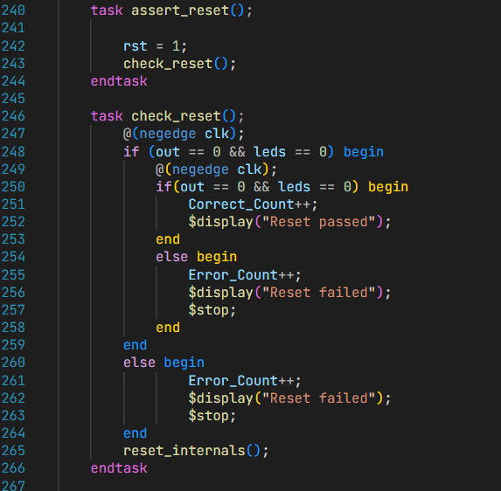

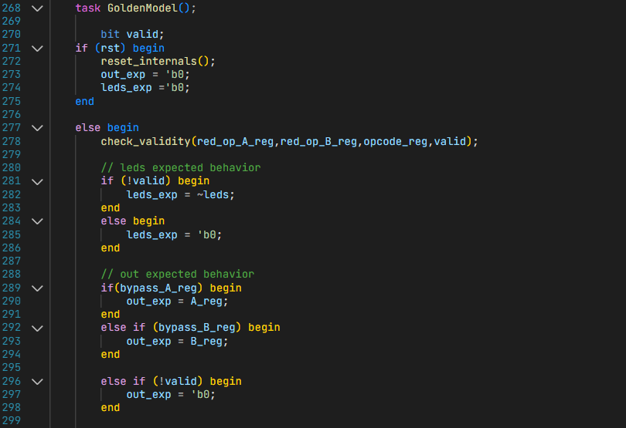

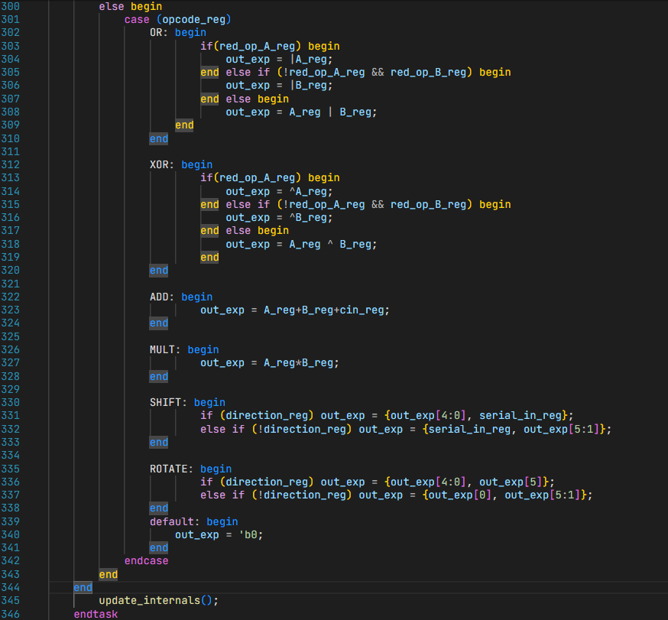

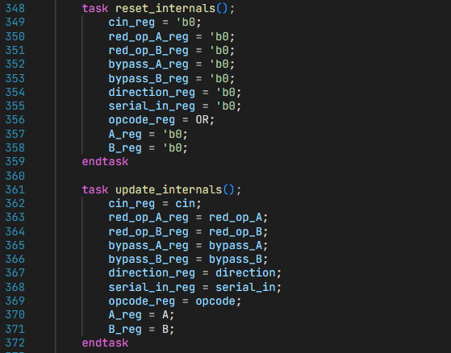

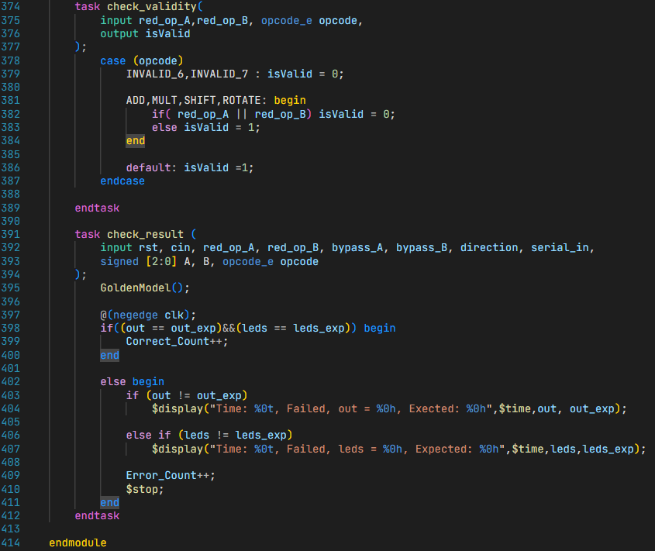

# Do file:

# Bugs found:

|  |  |  |
| --- | --- | --- |
| **Bug Description** | **Wrong code** | **Correction** |
| Internal wire (cin_reg) was defined to be signed, which causes sign extension in the addition processes. |  | Cin_reg should be unsigned, and no need to have a width more than one bit |
| The case statement should use the value of opcode_reg |  | Opcode → opcode_reg |
| Missing FULL_ADDER parameter check when opcode = add, hence, cin wasn’t taken into consideration |  |  |

# Results:

# 

# Waveform:

# Functional Coverage Report:

# 

# Coverage Report:

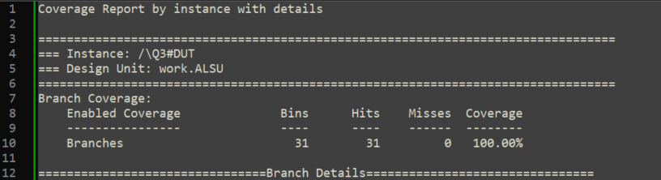

* Excluded **all False case** in the case statement, since invalid opcodes are handled by the flag (**invalid_opcode**)

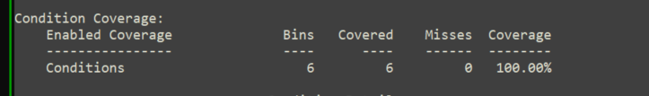

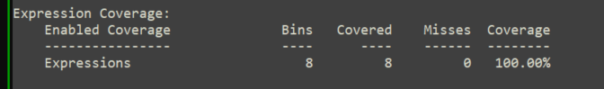

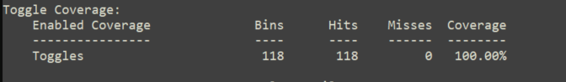

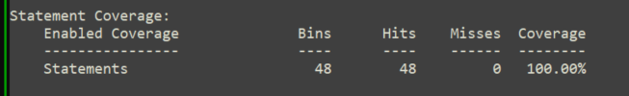

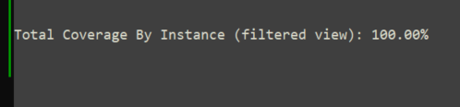

# Q4) RAM

# Verification Plan:

|  |  |  |  |  |
| --- | --- | --- | --- | --- |
| **Label** | **Design Requirement Description** | **Stimulus Generation** | **Functional Coverage** | **Functionality Check** |
| RAM1 | Check write functionality by generating 100 random values to be written on 100 different memory locations. | Random during the simulation | - | Comparing results to a refrence golden model |
| RAM2 | Check read functionality by reading the random 100 test verctors written and compare them to the excpected values. | Random during the simulation | **-** | Comparing results to a refrence golden model |

# TestBench:

# 

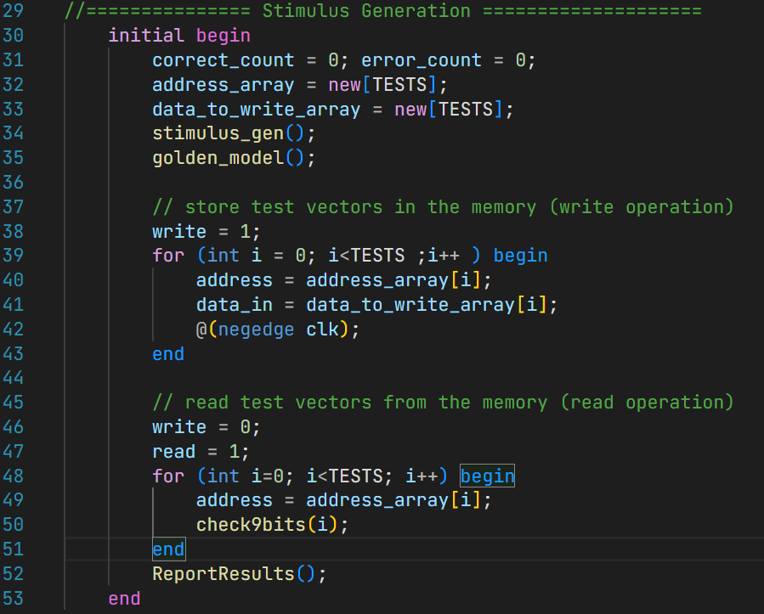

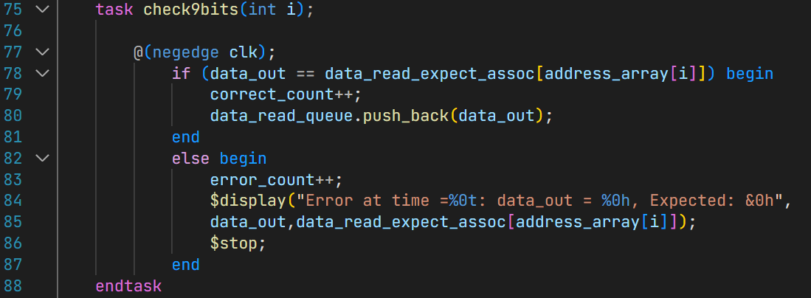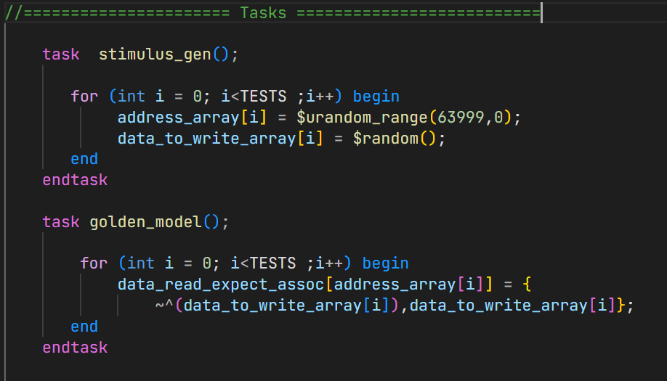

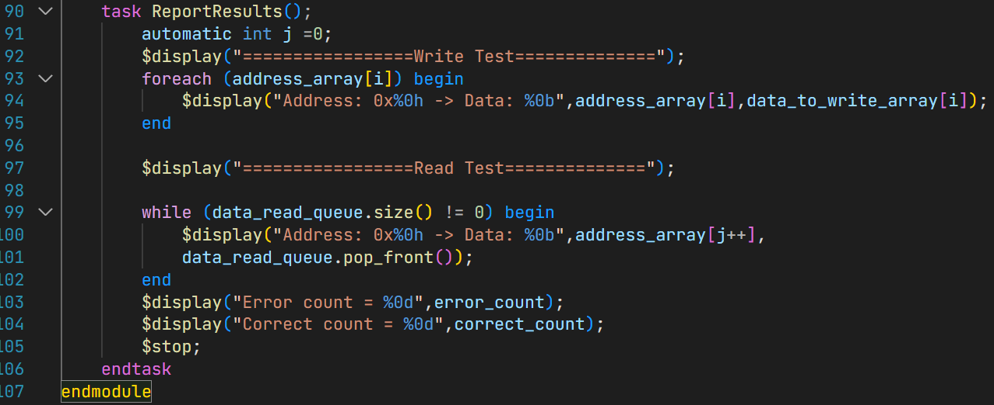

# Fixed Design:

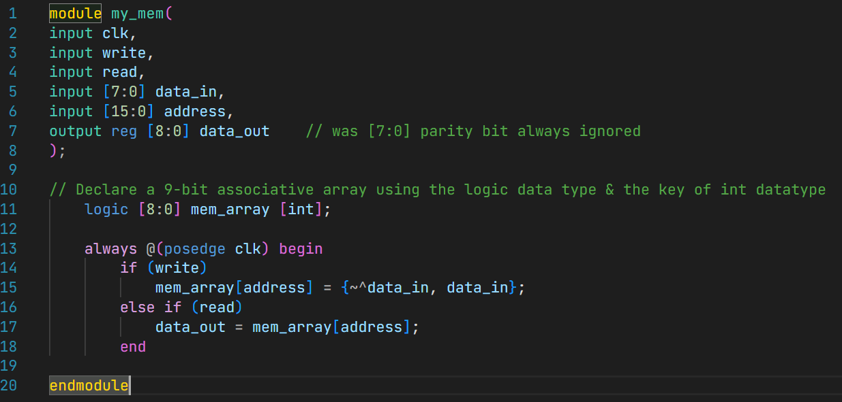

# Do file:

# Results:

# 

# 

# Waveform:

# 